**Walmart Sales SQL Queries**

--How many unique cities does the data have?

select count(distinct city) as unique_city from sales

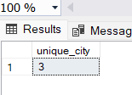

--In which city is each branch?

select distinct city,branch from sales

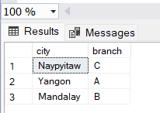

----How many unique product lines does the data have?

select distinct product_line from sales

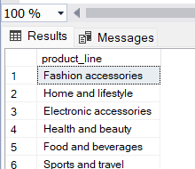

--What is the most common payment method?

Select top 1 payment,count(payment) as counts

from sales

group by payment

order by count(payment) desc

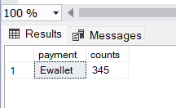

--What is the most selling product line?

select top 1product_line,sum(total) as amount

from sales

group by product_line

order by amount desc

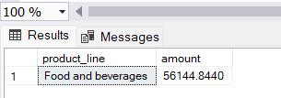

--What is the total revenue by month?

select month_name,sum(total) as total

from sales

group by month_name

order by month_name desc

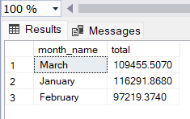

--What month had the largest COGS?

select

top 1 month_name,sum(cogs) as total_amount

from sales

group by month_name

order by total_amount desc

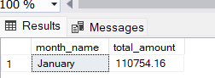

--What product line had the largest revenue?

select top 1 product_line,sum(total) as total_amount from sales group by product_line order by total_amount desc

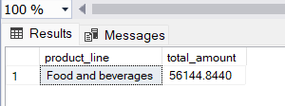

--What is the city with the largest revenue

select top 1 city,sum(total) as largest_revenue

from sales

group by city

order by largest_revenue desc

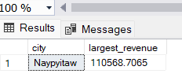

--What product line had the largest VAT?

select top 1 Product_line,

sum(VAT) as largest_VAT

from sales

group by product_line

order by largest_VAT desc

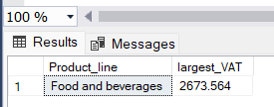

--Fetch each product line and add a column to those product line showing "Good", "Bad". Good if its greater than average sales

SELECT product_line, CASE WHEN SUM(total) > (SELECT AVG(total) FROM sales) THEN 'Good' ELSE 'Bad' END AS sales_status FROM sales GROUP BY product_line;

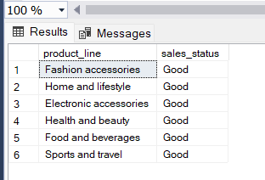

--Which branch sold more products than average product sold?

select branch,sum(quantity)

from sales

group by branch having sum(quantity) > (select avg(total_quantity) from (select sum(quantity) as total_quantity from sales group by branch) as a );

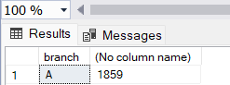

--What is the most common product line by gender

WITH GenderProductLineCount AS (

SELECT gender, product_line, COUNT(*) AS count

FROM sales

GROUP BY gender, product_line

),

MaxGenderProductLineCount AS (

SELECT gender, MAX(count) AS max_count

FROM GenderProductLineCount

GROUP BY gender

)

SELECT gplc.gender, gplc.product_line, gplc.count

FROM GenderProductLineCount gplc

JOIN MaxGenderProductLineCount mgplc

ON gplc.gender = mgplc.gender AND gplc.count = mgplc.max_count;

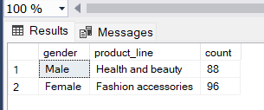

--What is the average rating of each product line?

select product_line, avg(rating) as avg_rating

from sales

group by product_line

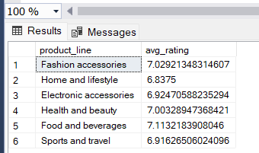

--Fetch each product line and add a column to those product line showing "Good", "Bad". Good if its greater than average sales

select product_line,avg(total),

case when sum(total) > avg(total) then 'Good'

else 'bad'

end

from sales

group by

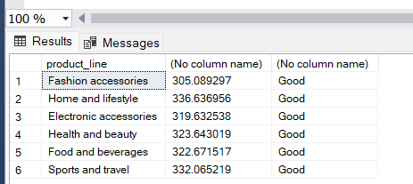

--Number of sales made in each time of the day per weekday

select time_of_the_day, day_name, sum(total) as total_sales

from sales where day_name <> 'saturday' and day_name <> 'sunday' group by time_of_the_day,day_name order by day_name

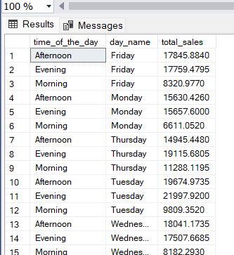

--Which of the customer types brings the most revenue

select top 1 customer_type,sum(total) as total_revenue

from sales

group by customer_type

order by total_revenue desc

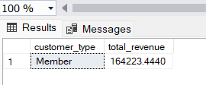

--Which city has the largest tax percent/ VAT (Value Added Tax)

select top 1 city,

max(vat) as VAT

from sales

group by city

order by vat desc

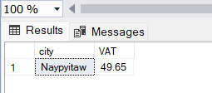

--Which customer type pays the most in VAT?

select customer_type, sum(vat) as vat

from sales

group by customer_type

order by vat desc

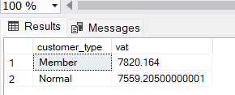

--How many unique customer types does the data have?

select count (distinct customer_type) as customer_type

from sales

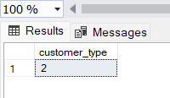

--What is the most common customer type

Select top 1 with ties customer_type, count(customer_type) as counts

From Sales

group by customer_type

order by counts desc

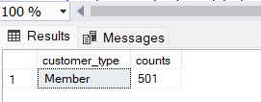

--Which customer type buys the most

select top 1 customer_type,sum(quantity) as product_sold

from sales

group by customer_type

order by product_sold desc

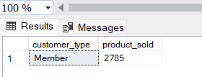

--What is the gender of most of the customers

select

top 1 gender,count(Quantity) as customers_count

from

sales

group by gender

order by customers_count desc

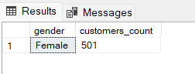

--What is the gender distribution per branch

select branch,count(gender) as gender_counts,

case when gender = 'Male' then 'M'

when gender = 'Female' then 'f'

end as gender

from sales

group by gender,branch

order by branch

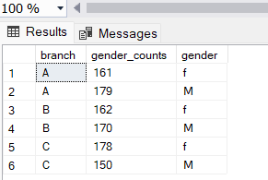

--Which time of the day do customers give most ratings

select count(rating) as rating_count,

time_of_the_day

from sales

group by time_of_the_day

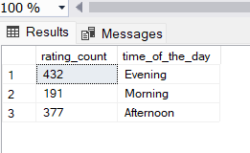

--Which time of the day do customers give most ratings per branch?

select max(rating_count) as max_count,branch

from (

select count(rating) as rating_count,branch,

time_of_the_day

from sales

group by time_of_the_day,branch) as a

group by branch

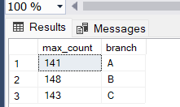

--Which day fo the week has the best avg ratings

select day_name,avg(rating) as rating

from sales

group by day_name

order by rating desc

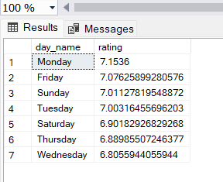

--Which day of the week has the best average ratings per branch?

select max(rating) as rating,branch,day_name

from

(select day_name, avg(rating) as rating,branch

from sales

group by day_name,branch ) as a

group by branch,day_name

